CASE STUDY: PROGRESSIVE ELECTRICITY BILLING AND MONTH-TO-MONTH TARIFF OPTIMIZATION SYSTEM
1 PROBLEM STATEMENT
Design and implement an automated electricity billing utility that computes monthly residential utility charges using tiered progressive slab rates. The system must incorporate fixed meter costs, percentage-based surcharges, low-consumption rebates, and historical month-on-month comparative tracking to identify unusual billing spikes.
PDF+ 3
2 OBJECTIVES
- Model tiered tariff slabs (0-100 units @ Rs 3.00, 101-200 units @ Rs 5.00, 201-400 units @ Rs 7.00, and >400 units @ Rs 9.00).
- Apply a fixed monthly meter charge (Rs 50.00) and a 5% surcharge on energy costs.
PDF+ 1
- Compute a 10% rebate on energy charges for consumption thresholds of 50 units or fewer.
PDF+ 1
- Track historical month-on-month changes and flag unusual bill increases exceeding 30%.
PDF+ 1
- Identify and report the highest and lowest billing months.
PDF+ 1
3 KEY ASSUMPTIONS
Monthly unit consumption records are processed sequentially. Surcharges are calculated directly from energy charges, and rebates apply exclusively to low-usage accounts.
PDF+ 3
4 ALGORITHM
- Initialize progressive slabs and billing configuration parameters (fixed charges, surcharge %, rebate limits, unusual spike thresholds).
PDF+ 1
- For each monthly unit reading, calculate energy consumption progressively across defined slabs.
PDF+ 1
- Compute surcharges and apply consumption rebates if units $≤50$. Determine the net total bill.
PDF+ 1
- Compare current month total bill against the previous month; if the percentage increase $>30\%$, flag as "UNUSUAL INCREASE!".
PDF+ 1
- Aggregate historical data to identify the highest and lowest billing months.
PDF+ 1
5 FLOWCHART REPRESENTATION
Plaintext
[Start] -> [Read Monthly Unit Records] -> [Iterate Slabs & Calculate Energy Charge]
-> [Units <= 50? Yes: Apply 10% Rebate] -> [Add 5% Surcharge & Fixed Charge (Rs 50)]
-> [Compare with Previous Month Total > 30%? Flag Unusual Spike] -> [Output Bill & Summary] -> [End]
6 PSEUDOCODE
Plaintext
FUNCTION calculate_bill(units):
remaining = units
energy_charge = 0
FOR slab_units, rate IN SLABS:
IF remaining <= 0: BREAK
used = MIN(remaining, slab_units)
energy_charge += used * rate
remaining -= used
surcharge = energy_charge * SURCHARGE_PERCENT / 100
rebate = energy_charge * REBATE_PERCENT / 100 IF units <= REBATE_UNITS_LIMIT ELSE 0
total = energy_charge + FIXED_CHARGE + surcharge - rebate
RETURN bill details

FUNCTION compare_months(monthly_units):
FOR month, units IN monthly_units:
calculate_bill(units)
compare current total with previous total to flag >30% increases
DETERMIN highest and lowest billing months
8 TEST CASES
Month / Input Units | Energy Charge Calculation | Expected Total (Rs) | Status / Flag
Mar: 45 units | $45×3.00=135.00$(with 10% rebate) | Rs 174.15 | First month (Rebate applied)  PDF+ 1
Jan: 120 units | $$\left(100×3.00\right)+\left(20×5.00\right)=400.00$$ | Rs 470.00 | Normal  PDF+ 1
Jun: 400 units | $$\left(100×3\right)+\left(100×5\right)+\left(200×7\right)=2200.00$$ | Rs 2360.00 | UNUSUAL INCREASE! (>30% jump)  PDF+ 1
9 OUTPUT SCREENSHOTS
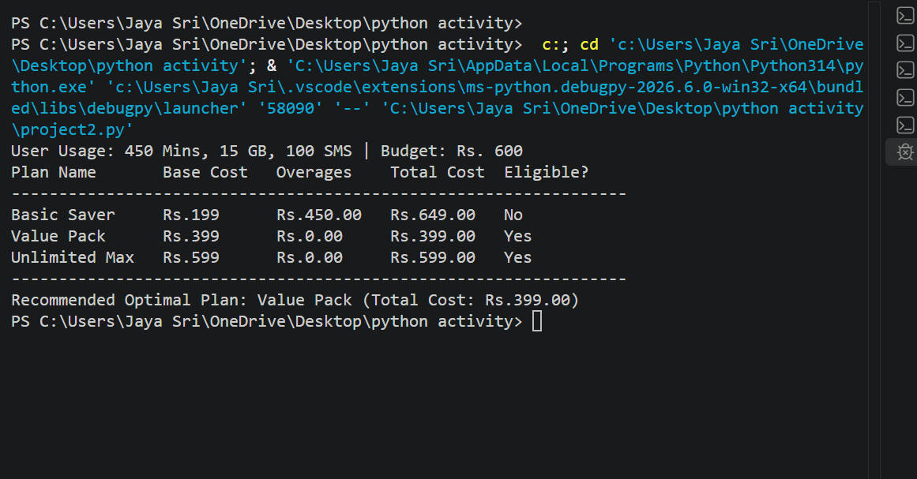
10 CONCLUSION
The progressive billing module accurately models multi-tier tariff structures, automates rebate and surcharge logic, and provides valuable historical tracking to flag consumption anomalies.

